The University of Virginia
School of Continuing and Professional Education

Northern Virginia Academic Center

ACCT 3110 – Intermediate Accounting I

Instructor: Leon W. Hutton, CPA, CGFM, SPHR

Leon.Hutton@cox.net or lwh7n@virginia.edu

703-447-6971 (cell)

Course Dates and Time – Spring 2014

Wednesdays, January 29 – May 7, 2014; 6:30pm – 9:30pm

Course Prerequisites

ACCT 2020 (Introductory Accounting II)

Course Description

This is the first course in intermediate-level accounting for business organizations (other than manufacturing concerns). The course provides an intensive study of generally accepted accounting principles for income measurement, cash and receivables, inventories, operational assets, and investments. This course covers Chapters 1 - 12 of the text.

Textbook

Intermediate Accounting, 7th Edition, Spiceland, Sepe, Nelson (Irwin/McGraw Hill, New York, Copyright 2013), ISBN: 978-0-07-744649-9 (Chapters 1 – 12)
ISBN: 978-0-07-761404-1 (combined edition)

Recommended but not required: Student Study Guide
We will not use “Connect” with this course.

Instructional Methodology

This course will use a combination of lecture/discussion and problem solving. Since this class is quantitative in nature, preparation is always important. Prior to each class, students are expected to have completed the assigned reading. Lectures may not cover every topic in detail. I encourage each student to also review and attempt to complete the assigned problems. We will cover each assigned problem in detail during class. The assigned problems are identified in the Course Schedule. Please participate in class by asking questions and/or making observations.

In addition, we will discuss, as appropriate, cases illustrating technical issues related to accounting practices, policies, and standards. These cases may be pulled from current events as published in newspapers such as The Wall Street Journal, Washington Post, professional journals such as The Journal of Accountancy, and monthly journals issued by professional organizations such as the Virginia Society of CPAs. As a course requirement, each student should identify, summarize and present information about one relevant article or event during the semester - further details will be discussed at the beginning of the semester.

Course Requirements

3 Examinations (30 points each) 90%
- Level and Quality of Participation (participating in class
discussions, asking contemplative questions on class discussions,
student presentations, attendance) 5%

Homework 5%

Grading Scale

90-100 points = A
80-89 points = B
70-79 points = C
60-69 points = D
Below 60 = F

The following illustrates how your examination scores, outside case and level and quality of participation will be used to compute your final course grade. Assume that you score 90 on each of the three examinations. Your final grade will be computed as follows:

90 + 90 + 90 = 270 /3 = 90 * .75 weight = 67.5

67.5 + 10 (level and quality of participation) + 5 (HW #1) + 10 (HW #2) = 92.5

The final course grade, for this illustration, is “A”.

Examinations

All scheduled examinations will be held in our classroom and will begin at regular class time. Each examination has a 3 hour time limit. Each examination is closed book and closed notes. You are expected to be present and to complete each exam on each date identified in the Course Schedule.

Late Examinations

If you cannot be present for a scheduled examination, please do the following:

Notify the instructor that you will not be present at the scheduled examination. This will give the instructor time to prepare an out-of-class examination for you. An out-of-class examination might be different from the one given during the regular scheduled time. If you do not notify the instructor and you are absent from the regular scheduled examination, the instructor will prepare an out-of-class examination for you and will deliver the out-of-class examination to Ms. Cindy Lu. Contact Ms. Lu at (703) 536-1117 and arrange a time to complete the examination. You must come to the Center to take the examination.

The University of Virginia requirement regarding late examinations (examinations completed at other than regular scheduled time in the course outline) follows: “Please note that permission to take an exam is only granted for extenuating circumstances. Late exams must be taken within 72 hours of the missed exam. Habitual late exam takers (those that have taken two or more exams in the past) may be denied this privilege.”

The Honor Code

Founded in 1842, the Honor System is one of the University's most cherished institutions. Based on the principle that University students want to be trusted, the Honor System helps create and strengthen a school-wide community of trust. Students at the University make a commitment not to lie, cheat or steal within Charlottesville, Albemarle County, or where they represent themselves as University students in order to gain the trust of others. Because they have made this commitment, students are trusted by peers, faculty members, administrators, and community residents alike. Students conduct themselves with integrity and are presumed honorable until proven otherwise. Students are recruited and trained by the Honor Committee to serve as advisors and to provide counsel. Students investigate Honor allegations, assist and support accused students through the Honor process, and work with accused students in their defense at trial. Honor jury panels are similarly comprised entirely of students. While anyone may initiate Honor proceedings, the process is administered entirely by students. The vitality of the Honor System depends upon the willingness of students to uphold the high standards set by their peers. When a student is formally accused of an Honor offense following investigation, that student may elect to either (1) leave the University, without requesting a trial (in which case that student will be deemed to have admitted guilt, whether or not such an admission is expressly made), or (2) request an Honor trial.

Any student found guilty of an Honor offense, or deemed to have admitted guilt after having left without requesting a trial, will be permanently dismissed from the University. The notation "enrollment discontinued" will be placed on the student's transcript, without specific reference to the Honor proceedings. In the case of a student found guilty of an Honor offense following graduation, or deemed to have admitted guilt without requesting a trial after graduation, the General Faculty of the University may undertake proceedings to revoke that student's degree. The rules of the Honor System apply to any person who was a University student at the time an alleged Honor offense was committed, so long as a case is initiated within two years thereafter. Students who enroll at the University benefit from the freedom and security provided by the Honor System; every student must agree to live by and support the spirit of honor.

Applicants who are not prepared to embrace this freedom and accept this responsibility should not apply for admission. This is intended as a brief summary of some important aspects of the University's Honor System. For more information, visit the Honor Committee Web page: www.student.virginia.edu/~honor.

If you have further questions, please call the Committee at (434) 924-7602.

The Honor Committee, June 2002

The following pledge should be written out at the end of all quizzes, examinations, individual assignments and papers: “I pledge that I have neither given nor received help on this examination (quiz, assignment, etc.).” The pledge should be signed by the student.

Special Needs Students

It is the policy of the University of Virginia to accommodate students with disabilities in accordance with federal and state laws. Any SCPS student with a disability who needs accommodation (e.g., in arrangements for seating, extended time for examinations, or note-taking, etc.), should contact the Learning Needs and Evaluation Center (LNEC) and provide them with appropriate medical or psychological documentation of his/her condition. Once accommodations are approved, it is the student’s responsibility to follow up with the instructor about logistics and implementation of accommodations.

If students have difficulty accessing any part of the course materials or activities for this class, they should contact the instructor immediately. Accommodations for test-taking should be arranged at least 14 business days in advance of the date of the test(s). A student’s academic dean is also available to assist with accommodations, particularly for temporary or emergency situation. Please email SCPSaccommodation@virginia.edu.

Students with disabilities are encouraged to contact the LNEC: 434-243-5180/Voice, 434-465-6579/Video Phone, 434-243-5188/Fax. Web: http://www.virginia.edu/studenthealth/lnec.html.

Unofficial Transcript and Transcript Order

Here are the directions to access grades (unofficial transcript)

The University of Virginia does not mail out grades. Grades are available through SIS (Student Information System) online.

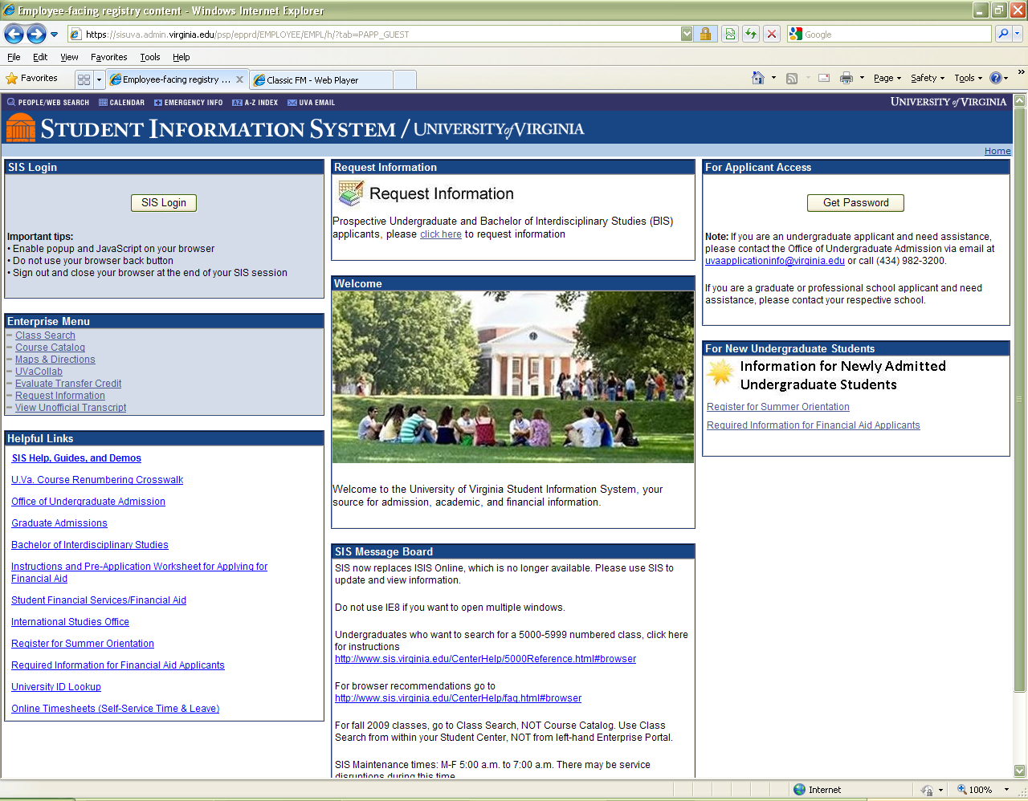
Go to https://sisuva.admin.virginia.edu/psp/epprd/EMPLOYEE/EMPL/h/?tab=PAPP_GUEST

Select View Unofficial Transcript in the Enterprise Menu.

Enter information in the next screen.

To order a transcript: http://www.virginia.edu/registrar/transcript.html. Transcripts are issued at $10 per copy.

Course Schedule
Session Topic(s)

Jan 29 Introductions, Chapters 1 and 2: The Environment and Theoretical
Structure of Financial Accounting; Review of the Accounting Process

Feb 5 Chapter 3: The Balance Sheet and Financial Disclosures

Feb 12 Chapter 4: The Income Statement and Statement of Cash Flows

Feb 19 Chapter 5: Income Measurement and ProfitabilityAnalysis;
Review for Exam #1

Feb 26 Exam # 1 (Chapters 1 – 4)

Mar 5 Chapter 6: Time Value of Money

Mar 12 Chapter 7: Cash and Receivable

Mar 19 Chapter 8: Inventories: Management

Mar 26 Chapter 9: Inventories: Additional Issues; Review for Exam #2

Apr 2 Exam # 2 (Chapter 5 – 8)

Apr 9 Chapter 10: Operational Assets: Acquisition and Disposition

Apr 16 Chapter 11: Operational Assets: Utilization and Impairment

Apr 23 Chapter 12: Investments

Apr 30 Student Presentations, Review for Exam #3

May 7 Exam #3 (Chapters 9 – 12)

At the end of each chapter are “CPA and CMA Exam Questions.” Students planning to
sit for either exam should invest the extra time to complete those questions. Answers will
be provided upon request. The authors also provide “Alternative Problems.”
Answers to these problems will also be provided upon request.

FASB Codification Student Access

http://aaahq.org/ascLogin.cfm

Student Access
Username - AAA53195
Password - mkSfgcW

Useful Websites

www.aicpa.org/BecomeACPA/CPAExam/ForCandidates/HowToPrepare/DownloadableDocuments/New_2011_CPA_exam_guide_to_CBTe.pdf

http://www.aicpa.org/BecomeACPA/CPAExam/Pages/CPAExam.aspx

Homework Problems

Chapter 1: E1-1, E1-4, E1-7, E1-9, E1-14, E1-15

Chapter 2: E2-1, E2-2, E2-5, E2-13, E2-17, E2-18

Chapter 3: E3-1, E3-2, E3-3, E3-5, E3-7, E3-9, E3-15, E3-16

Chapter 4: E4-1, E4-2, E4-3, E4-5, E4-7, E4-11, E4-12, E4-16, E4-22

Chapter 5: E5-1, E5-2, E5-3, E5-4, E5-5, E5-6, E5-11, E5-13, E5-14, E5-18, E5-22, E5-23, E5-25

Chapter 6: E6-1, E6-2, E6-3, E6-4, E6-5, E6-6, E6-7, E6-8, E6-9, E6-10, E6-11, E6-17, E6-21

Chapter 7: E7-1, E7-2, E7-5, E7-6, E7-7, E7-8, E7-10, E7-14, E7-15, E7-22, E7-24

Chapter 8: E8-1, E8-2, E8-3, E8-4, E8-5, E8-6, E8-7, E8-8, E8-9, E8-10, E8-13, E8-14, E8-19, E8-24

Chapter 9: E9-1, E9-3, E9-8, E9-11, E9-13, E9-14, E9-15, E9-16, E9-29

Chapter 10: E10-1, E10-2, E10-3, E10-4, E10-6, E10-8, E10-9, E10-13, E10-14, E10-15, E10-20, E10-23, E10-25, E10-27, E10-29, E10-30, E10-31

Chapter 11: E11-1, E11-2, E11-3, E11-4, E11-5, E11-9, E11-10, E11-13, E11-14, E11-18, E11-19, E11-22, E11-25, E11-26, E11-34

Chapter 12: E12-1, E12-2, E12-4, E12-5, E12-7, E12-8, E12-11, E12-13, E12-16, E12-19, E12-21, E12-22, E12-23

