Syllabus for Chemistry 1810 (2020)
Principles of Chemical Structure

Course: CHEM1810, Part I of a four-semester sequence covering chemical principles and reactions.
Location and Time: Tues, Thurs 9:30 am – 10:45 pm
Lectures delivered synchronously online via Zoom.
Professor: W. Dean Harman
Office hours: Tues, Thurs 10:45-12:00 noon
Phone: (o) 924-3060; (h) 973-9352 (before 10 p.m. please)
e-mail: wdh5z@virginia.edu
Problem Sessions: Tuesdays 7-9 pm
Final Grade: each of three exams will count 25% towards your final grade. Problem Sets will also count 25%.

Exams: Three exams (three hours allowed for each) will be held on Tuesday, September 29th, (7-10 pm) Tuesday, Nov 3rd (7-10 pm), Friday, December 11th 2:00 – 5:00 pm. A student must submit a written request one week in advance to alter an examination date. Exams must be completed without aid from other individuals.

Honor Policy:
I trust every student in this course to fully comply with all of the provisions of the UVA honor system. In addition to pledging that you have neither received nor given aid while taking your exam, your signature also affirms that you have not accessed old exams, answer keys, or the textbook while taking an exam and that you have not obtained any answers from another student (hand-written lecture notes are allowed).
Homework problems may be discussed with others (strongly encouraged). All re-grades will be handled directly by the professor. A test may be submitted for a re-grade only once. The test must be submitted within one week after the examination date. At the option of the professor your entire test may be re-graded. A test re-submission constitutes the student's final appeal. Any attempt to use external resources during an exam or alter a graded examination shall constitute an honor violation and will result in no credit for that exam, and possible disciplinary action by the Honor Committee.
If, in my judgment, it is beyond a reasonable doubt that a student has committed an honor violation with regard to a given exam, that student will receive an immediate grade of 'F' for that exam, irrespective of any subsequent action taken by the Honor Committee. W. D. Harman

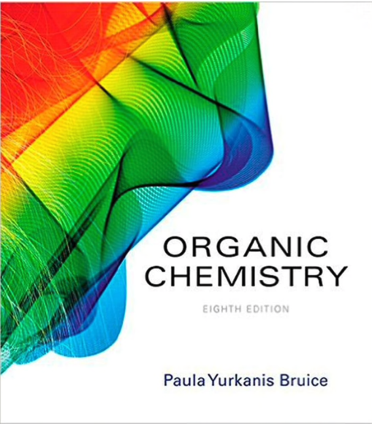
Required:
• BRUICE - ORGANIC CHEMISTRY (8th Ed)
(available at the UVA bookstore, Amazon, etc.; hard copy or e-text options)

• Model Kit for General and Organic Chemistry (Prentice Hall)
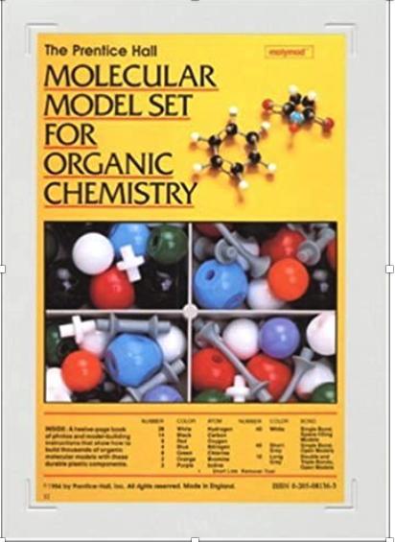
ISBN-13: 978-0205081363

• Thinkwell Chemistry (300 video tutorials)
(discounted for UVA students)
1. Go to: Thinkwell.com to purchase.
2. Click on “Register”
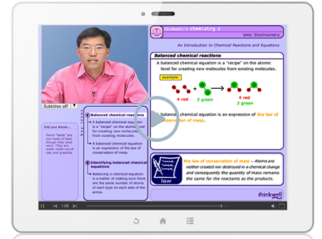
3. Type in "Virginia" and register for "CHEM1810-Fall 2020-Harman"
4. Choose Chemistry Companion (cost should be $75 (NOT $150))
5. Checkout with credit card

Dropping the Course: The College drop date is October 13th; dropping before this date removes the course from your record. The last day to withdraw from a College course is October 27th (A "W" will appear on your transcript).

Laboratory. A laboratory course, CHEM 1811, may be taken concurrently with CHEM 1810. This course is fully independent of CHEM 1810.

Topics of CHEM1810:
(dates are approximate)
I. Fundamental Principles and Particles (5 lectures: 8/25/20 - 9/8/20)
Energy and Elementary Particles
Dual Nature of Light
Mass Spectrometry
Nuclear and Chemical Stability

II. Introduction to Quantum Mechanics (5 lectures: 9/10/20 - 9/24/20)
The Hydrogen Atom
Polyelectronic Atoms
Periodicity

III. Molecules: (7 lectures: 9/29/20 - 10/20/20))
Diatomic Molecules and MO theory
Polyatomic Molecules with Localized π Systems
Stereochemistry
IV. Molecular Spectroscopy: (5 lectures: 10/22/20 - 11/5/20)
IR Spectroscopy
Nuclear Magnetic Resonance Spectroscopy
V. Advanced Orbital Interactions (5 lectures: 11/10/20 - 11/24/20)
Delocalized π systems
Transition Metal complexes

