Multi-functional Integrated System Technology (MIST) Center

University of Florida, Gainesville, FL (Lead University)
University of Central Florida, Orlando, FL (Partner University)
University of Virginia, Charlottesville, VA (Partner University)

- CENTER BYLAWS -

ARTICLE I - INTRODUCTION
1.1 The following Bylaws will be used to govern the Multi-functional Integrated System Technology (MIST) Center, a National Science Foundation (NSF) Industry/University Cooperative Research Center (I/UCRC).
1.2 The Bylaws can be amended at any time by an affirmative two-thirds vote by the Industrial Advisory Board (IAB) with the exception of conditions described in Section 1.4.
1.3 The MIST Center is a university consortium comprised of the following participating University Sites:
University of Florida, Gainesville, FL (Lead University)
University of Central Florida, Orlando, FL (Partner University)
University of Virginia, Charlottesville, VA (Partner University)
1.4 These Bylaws form part of the Membership Agreement with participating Members. In case of conflict between the Membership Agreement and these Bylaws, the Membership Agreement rules.

ARTICLE II - PURPOSE
2.1 The vision of the MIST Center is “Innovating More than Moore technologies for smart systems in the Internet of Things era.”
2.2 The mission of the MIST Center is to facilitate integration of novel materials, processes, devices and circuits into multi-functional systems through research partnerships between university, industry, and government stakeholders.
2.3 The MIST Center is motivated by three related research/industry opportunities:
- Stepping beyond the current challenge of continued conventional scaling of integrated circuits, a.k.a. Moore’s Law,
- Exploring new functionalities possible at intersections of materials/processes/devices/circuits for multi-functional systems, and
- Integrating nanoscale materials into micro/nanosystem manufacturing.

ARTICLE III - MEMBERSHIP
3.1 The MIST Center is supported by a combination of financial support from NSF, the University Sites, and annual Membership Fees from Member organizations. Membership Fees are used primarily to support Center research.
3.2 A Company, Corporation, Federal Agency, Federal Research and Development organization, Government-owned Contractor Operated laboratory, Institute, Association, or other type of organization may become a Member of the MIST Center by signing the Membership Agreement at one University Site and paying Membership Fees to the respective University Site. Except for identifying the university, the membership agreement is the same for all sites. In addition, Institutes and Associations must also sign an Addendum to the MIST Center Membership Agreement(s) for Institutes and Associations.
3.3 Membership Fees are paid in any increment of $1,000/year, where each $1,000 corresponds with 1 IAB vote by the Member organization (for the project selection process). A Member organization must meet the following minimum membership level at one University Site thereby establishing one Full Membership in the MIST Center:
- Large organizations (200 or more full time employees): $50,000/year
- Small organizations (less than 200 full time employees): $25,000/year
Once the minimum Full Membership is met, a Member organization may direct additional Membership Fees to the same University Site and/or additional University Sites. However, the maximum voting power of any one member organization is limited as specified in Article IX.
3.4 After meeting the requirements of one Full Membership in the MIST Center, a Member may contribute additional Membership Fees (including “In Kind” support) to any University Site to enhance or extend any active Research Project(s) within the Center research portfolio (“Enhancement Funds”). Enhancement Funds may be contributed to a University Site at any time. Enhancement Funds must not interfere with or dilute any active Center-funded Research Projects. Enhancement Funds may only be applied to active Research Project(s) that were selected/funded using the procedures defined in Article VIII and Article XIII. The scope and period of performance of all Enhancement Funds must meet two-thirds approval by the IAB. Enhancement Funds do not count toward meeting Membership requirements in the Center (Article III) nor provide additional voting power for annual Project Selection (Article VIII). All research results and intellectual property associated with a Research Project receiving Enhancement Funds will remain available to all Center Members pursuant to the terms in these Bylaws.
3.5 A recovery of indirect costs (F&A) by any University Site shall be limited to 10% of all center Membership Fees collected from each Member. The difference between the actual recovery of indirect costs (limited to 10%) and the University Site’s normal allowable indirect costs (typically ~50%) constitutes a cost-share match in connection with the Member’s cash Membership Fees to support Center research in accordance with the requirements of the National Science Foundation I/UCRC Program Solicitation NSF 13-594.
3.6 An “In-Kind” membership is possible on an annual basis by receiving approval by two-thirds vote of the IAB. A Member organization that provides “In-Kind” Membership Fees in lieu of cash payments will provide a listing of categorized items to be considered as its “In-Kind” support for approval.

ARTICLE IV - ORGANIZATION

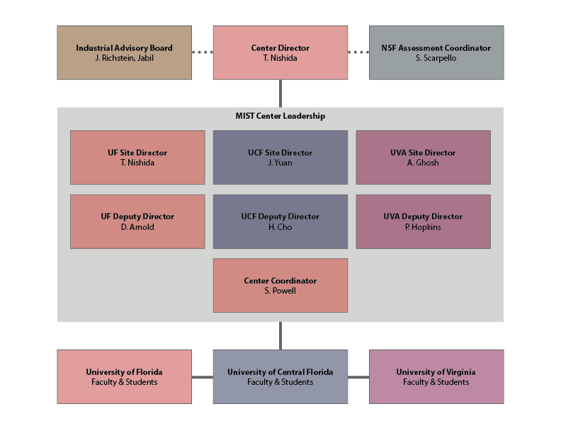
Figure 1. MIST Center organizational structure.

4.1 Although individual Members of the Center join the Center through different University Sites, there is only one IAB for the Center. The IAB comprises delegates from each Member organization. A Member organization can send as many delegates to the IAB meetings as it considers appropriate. Voting procedures are detailed in Article IX.
4.2 The IAB will elect by majority vote a Chair and a Vice Chair (Chair-Elect) for a two-year term after approval of the Bylaws and no less than every two years thereafter. Generally, the Vice Chair will become the IAB Chair when a new Vice Chair is elected by the IAB.
4.3 The IAB will participate in the strategic planning of the Center and will assist the participating faculty in identifying pre-competitive, generic, industry-related, research problems in multi-functional integrated system technology. Furthermore, the IAB will recommend Research Projects for future work; provide direction/recommendations for ongoing Research Projects; assist in identifying appropriate industrial internship opportunities for students; assist the Center Director and Site Directors in recruiting new sponsors; review the research and educational programs and accomplishments of the Center; and recommend mid-course changes and clarification of expected deliverables to meet IAB needs and concerns.
4.4 The Center Director will be responsible for all Center activities and will report directly to the Dean of Engineering at the University of Florida and the IAB. The Center Director will be Dr. Toshikazu Nishida. In the event Dr. Nishida is unable to serve, the Dean of Engineering at the University of Florida will appoint a successor Center Director subject to confirmation by a two-thirds vote of the IAB.
4.5 The Site Directors at the Partner Universities will be responsible for Center activities at their respective institutions. They will report directly to their respective appropriate university administrators and to the Center Director. The Site Directors will liaise between the Center and the appropriate academic departments of the member universities.
4.6 Project Principal Investigators will manage specific Research Projects funded by the Center and will report directly to the appropriate Site Director. Project Principal Investigators will be identified in all project proposals.
4.7 The Partner University Site Director(s) will be: Dr. Jiann-Shiun (Peter) Yuan at the University of Central Florida and Dr. Avik Ghosh at the University of Virginia. If a Site Director becomes unable to serve, the participating university will appoint a successor Site Director subject to confirmation by a two-thirds vote of the IAB.
4.8 A NSF Assessment Coordinator, appointed by the NSF, will assist the Center Director, Site Directors, and the IAB to organize the Center and provide an independent assessment of the operation. The NSF Assessment Coordinator will report directly to the I/UCRC Program Manager at the NSF.
4.9 University Policy Committees: A University Policy Committee for each Site will be comprised of individuals from the University Administration. This Committee shall not have any overlap with the members of the Center Academic leadership team. The purpose of each University Policy Committee is to provide oversight to ensure Center compliance with the respective university policies and regulations and to resolve any and all Center administrative issues, including review of academic standards, recruitment strategies, retention issues, funding issues, space requirements, and equipment requirements related to the Center.
4.10 Administrative Support Staff: The Lead University and each Partner University will provide a reasonable level of clerical and accounting support for the operation of the Center.

ARTICLE V - ADMINISTRATION
5.1 The Center Director and Site Directors will work with the IAB on strategic plans for the Center and on recruiting new Members.
5.2 The Center Director in cooperation with the Site Directors will submit an annual operating and research budget to the IAB for review and recommendations. This will be available for review at least 14 days prior to the Fall IAB Meeting each year.
5.3 The Center and Site Directors, upon approval of the IAB, will authorize the use of Membership Fees by the Project Principal Investigators in support of Center research.
5.4 The Site Directors will work with the appropriate departments on recruiting graduate students for the Center and will set standards for student participation; monitor student progress towards a degree; set goals for recruiting students (especially minority and women); promote the multidisciplinary nature of the research program; and, help students to organize industrial internships. The Site Director will develop a strategy to integrate the technologies and research activities of the Center into the academic curriculum at each participating university to the maximum extent possible.
5.5 Each student or postdoc participating in Center research will have a Center faculty mentor. The faculty mentor is responsible for advising the student or postdoc on university, departmental, and Center policies.
5.6 Each project funded by the Center shall have at least one—preferably two or more—IAB mentors assigned to the project. IAB mentors will serve as primary points of contact with the IAB for the Project Principal Investigators.
5.7 Each University Site shall require its students and employees who perform research activities to assign their undivided interests in any resultant inventions to the respective University.
5.8 Each Member organization will designate one delegate (“Focal”) as the primary point of contact for all Center-related communications.
5.9 The Center operates on an annual operational year defined from January 1 to December 31 of each calendar year. Research Projects, Membership Fees, and Membership (and rights of membership) all correlate with this operational year.

ARTICLE VI - REPORTS
6.1 The Center Director shall provide an annual project status and operations report to the Members and to the NSF.
6.2 The Site Directors and Project Principal Investigators shall provide interim reports to the Center Director and to the Members as necessary at the completion of major research tasks. These interim reports will be distributed via the Center web site and email notification to all Members once posted.
6.3 All administrative issues, concerns or conflicts regarding the activities of research and reporting are responsibilities of the Center Director.

ARTICLE VII - MEETINGS
7.1 The Center Director, Site Directors, and the IAB Chair will establish the schedule of activities and meetings for the Center as well as the agenda for the semiannual Center meetings.
7.2 The participating University Site personnel, Center Director, Site Directors, and IAB will meet semiannually (fall and spring) for the purpose of research review. The University Sites will host the Center meetings on a rotating basis with the date and location announced at the previous Center meeting. Center Member organizations are welcome to host/sponsor a Center meeting with the approval of the Center Director, Site Directors, and a two-thirds vote of the IAB.
7.3 Center meetings are closed to the public. Attendance is limited to faculty, staff, postdocs and students affiliated with the Center; representatives of Members; the NSF Assessment Coordinator; and other NSF personnel. Guests, observers, and potential Center members may be permitted to attend with approval by the Center Director, Site Directors, and IAB Chair and only after signing a Confidential Disclosure Agreement.
7.4 The IAB will meet twice a year to review research results, select projects, review budgets, and discuss the strategic plans for the Center. The IAB meetings will coincide with the semiannual Center meetings. IAB meetings are restricted to Member delegates, the NSF Assessment Coordinator, and NSF personnel.
7.5 The University Policy Committees will meet as necessary to discuss and resolve Center program and management issues.

ARTICLE VIII - RESEARCH PROJECT SELECTION PROCEDURE
8.1 A major activity of the MIST Center is to execute Research Projects. Research Projects will generally be conducted by undergraduate students, graduate students, and postdocs under the direction of one or more faculty PI’s at each University Site. Each Research Project is associated with one or more University Sites where the research activities will take place. Collaborative projects across multiple University Sites are encouraged to promote operating as a Center as opposed to a loose combination of independently operating sites. All Center Members may participate in the discussions, advisement, evaluation, and recommended future direction of Research Projects.
8.2 Through discussion with Center Members, each University Site will develop a set of Research Project proposals consistent with the goals of their faculty/students, the interest of the Members, and the mission of the Center. The proposals, including rough order of magnitude pricing, will be circulated to the Members at least two weeks prior to the Fall IAB meeting.
8.3 At the fall Center meeting, faculty/student teams will present their proposals to the IAB delegates. IAB delegates from each Member organization will then cast votes for individual Research Projects during the IAB meeting (the number of votes allocated to each Member are defined in Article IX). Members can allocate their votes to one or more Research Project(s) at any University Site. Absentee ballots may be cast if a Center Member is unable to send delegates to the IAB meeting.
8.4 Based on the outcome of this voting procedure, the IAB will recommend funding of projects and will cooperate with the Center Director to establish an annual budget for one or more Research Projects. The research project selection by the IAB will be guided by a set of Voting Principles: to strengthen the overall MIST Center, to provide more value to each member than it puts into the Center, and to utilize at least 90% of the membership fees to directly support research (the remainder for University Site indirect costs, where incurred, and other administrative overhead costs to run the Center.)

ARTICLE IX - VOTING
9.1 The number of votes allocated to each Member is only determined by the Membership Fees paid by that company irrespective of the number of delegates it may have associated with MIST Center at any given time.
9.2 Voting on MIST Center project selection will be based on Membership Fees (cash contributions only). A Member will get one project vote for every $1,000 of annual membership fee paid. For example, a $53,000 annual membership fee is equivalent to 53 votes. However, the maximum project voting power of any one Member is limited to 100 votes for large organizations and 50 votes for small organizations (large and small organizations are defined in Article 3.3). This voting cap does not limit the amount of funding that a Member may contribute to the MIST Center.
9.3 Voting on any issues related to MIST Center, other than project selection (e.g. policies and operations), will be based on one vote per Full Membership subject to a maximum of two votes per member. A Full Membership is defined as the minimum membership level specified in Article 3.3. For example, a large organization that contributes at least $50,000 and less than $100,000 will have one vote, while a large organization that contributes at least $100,000 will have two votes.
9.4 Voting decisions on all issues related to MIST Center, other than project selection, require a two-thirds approval of the available IAB votes, unless otherwise specified in these Bylaws.
9.5 Each Member that joins the Center on an approved “In-Kind” basis will be allowed to vote on all Center matters except project selection. However, such members can participate in the evaluation and discussion of Research Projects.

ARTICLE X - PUBLICITY
10.1 A Member shall not use the name of any University Site in any publicity, advertising or news release without the prior written approval of an authorized representative of the affected University. Likewise, no University Site may use the name of a Member in any publicity without the prior written approval of the Member. Press releases will be coordinated between the Center Director and participating press offices. Notwithstanding the forgoing parties may satisfy any reporting requirements of their respective organizations.
10.2 Subject to the recommendations of the IAB, the Center Director may post the titles and descriptions of all Center Research Projects on the Center web site. The descriptions shall not contain confidential or proprietary information and may be published freely.

ARTICLE XI - PUBLICATIONS AND INTELLECTUAL PROPERTY
11.1 Researchers engaged in Center Research Projects shall be permitted to disclose the methods and results of their research after a review by the Members for intellectual property as outlined in the Membership Agreement.
11.2 At any time, a Site Director may request permission to publish Center information presented in summaries, semiannual reports, annual reports, or final reports; or arising out of or resulting from Research Projects; in the form of abstracts, presentations, or manuscripts. To receive permission, the Site Director shall submit a “Request for Permission to Publish” containing the information to be published in the form in which publication will be sought to the Members. The Request will be sent by email from the Site Director to the IAB Chair, who will forward to each Member. The information in the Request may be published in a substantial form (as submitted with the Request) if after thirty (30) days, no Member has objected in writing to the publication of such information. A Member may object if the publication contains patentable subject matter that requires protection and/or the publication contains Member’s confidential information. In such cases, publication will be delayed up to ninety (90) days to allow for patent applications to be filed or confidential information to be removed. It is understood that in no case can this provision for delay of publication cause an unreasonable delay in the normal academic progress of a graduate student at a University Site with respect to preparation and submission of a graduate thesis or dissertation.
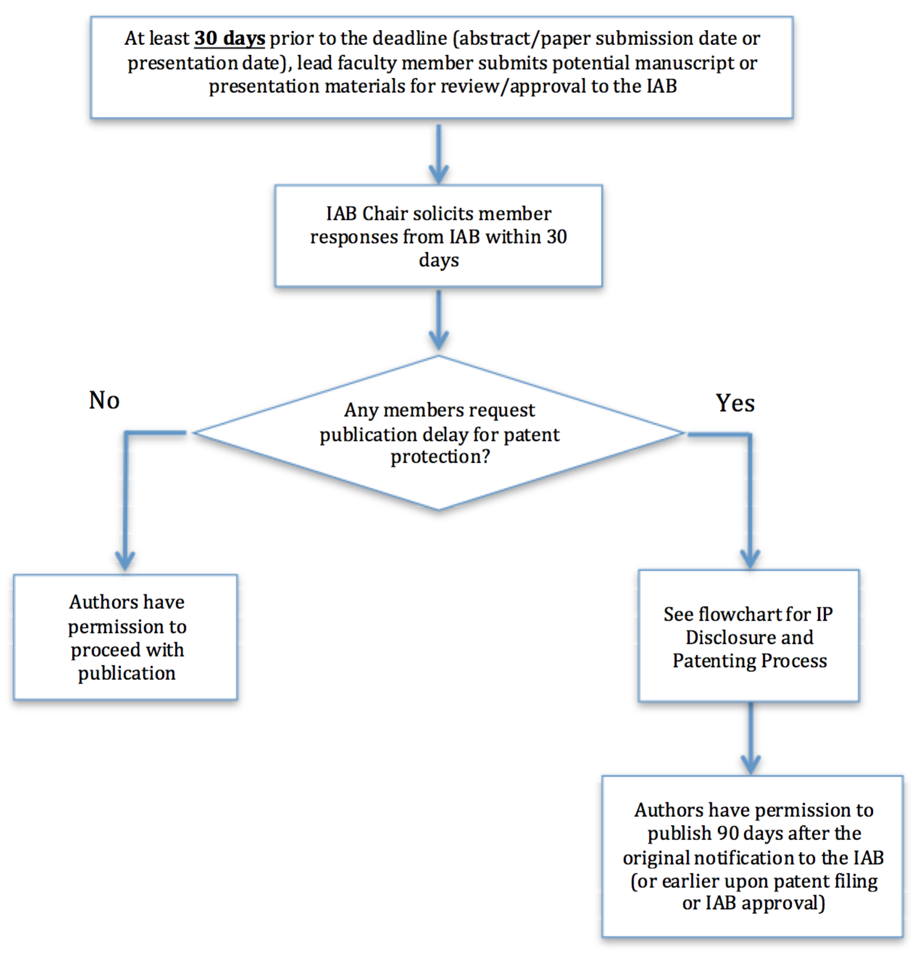
Figure 2. MIST Center publication flowchart.
11.3 Upon invention of any patentable technology that is funded in whole or in part by the MIST Center, University participants (faculty, students, postdocs) will file an invention disclosure at their respective University Site. Upon submission of an invention disclosure (called an “IP Event”), the Center Director or Site Director will promptly notify all Center Members and provide supporting documentation. Members have thirty (30) days to indicate non-binding interest in licensing the technology (intellectual property). Failure to respond with thirty (30) days indicates waiver of non-exclusive licensing rights. After this thirty (30) day period, the University will begin negotiations for licenses with all interested Center Members.
11.4 A Member may only exercise licensing rights if it is a member in the year that the technology (intellectual property) was created.
11.5 It is typical that all patent expenses incurred by the University will be split equally to Members who negotiate a license for the underlying technology (intellectual property).
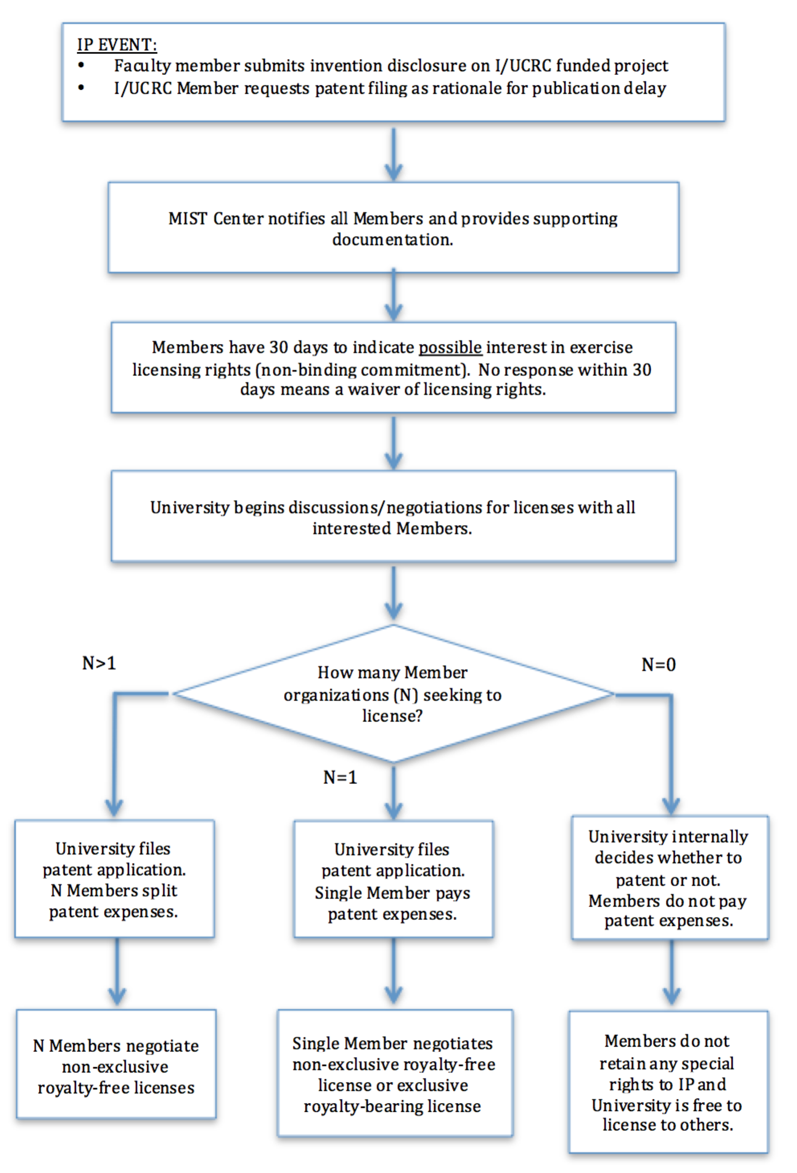
Figure 3. MIST Center intellectual property flowchart.

ARTICLE XII- BENEFITS
12.1 All Members will have non-exclusive rights to the entire MIST Center research portfolio and intellectual property across all University Sites under the conditions outlined in the Membership Agreement and in Article XI.
12.2 All Members will have an opportunity to directly contribute to MIST Center research and education programs by serving as industrial mentors and/or thesis committee members as appropriate and consistent with the policies and procedures of participating Universities.
12.3 All Members will have an opportunity to propose case study problems, specific research problems, and focus areas for research.
12.4 All Members will have an opportunity to host postdocs, graduate and undergraduate students as industrial interns.
12.5 Technology transfer between the faculty/student research teams and Members will be promoted by:
- Pre-doctoral and post-doctoral industrial internships;
- The direct involvement of the industrial advisor on the research team;
- Web-based submission of reports
12.6 Each Member that joins the Center by paying a Membership Fee will vote on the selection of Research Projects supported by Membership Fees. They will also be eligible to vote on all other Center matters and participate in the evaluation and discussion of Research Projects. Voting procedure is outlined in Article IX.

ARTICLE XIII- NEW UNIVERSITY SITES AND INDUSTRIAL SPONSORS
13.1 New universities may request participation in the MIST Center as an affiliated University Site. Each new university requesting participation shall initially obtain concurrence from the Center Director, Site Directors, two-thirds vote of the IAB, and the I/UCRC Program Manager at the NSF prior to submitting a “Letter of Intent” to join MIST Center. Universities requesting participation as an affiliated site must demonstrate their ability to perform synergistic research within the focused research areas of the Center and their willingness to work within the structure, policies and procedures of the MIST Center. Upon concurrence by the Center, the new university requesting participation as an affiliated site may continue application per the applicable procedures of the current NSF I/UCRC program solicitation.
13.2 A new university requesting participation in MIST Center shall review their research objectives and program plans, and, obtain and submit within their Planning Grant Proposal a “Letter of Support” from the Site Director at each of the current Center university members.
13.3 New Companies, Corporations, or Organizations may request, or be requested, to join a University Site of the MIST Center as a Member. These new Companies, Corporations, or Organizations may join the MIST Center upon signature of the existing Membership Agreement, signature of the Membership Agreement Addendum for Institutes and Associations (only applies to institutes, associations, and consortia), acceptance of the current Bylaws, and payment of the NON-PRORATED annual membership fee. Application of these new Membership Fees shall be made to existing Research Projects at the affiliated site unless a new “interim” Research Project is otherwise approved by the Center Director, Site Directors, and a two-thirds vote of the IAB. Continued funding of the “interim” Research Project is subject to IAB approval at the next annual IAB meeting under the terms of these Bylaws.

ARTICLE XIV- OUTREACH AND BROADER IMPACTS
14.1 The Center Director and Site Directors at each university will develop a Broader Impacts Plan to ensure that MIST Center promotes collaborations within the community through local, regional, national and international participation in the Center’s activities. Teaming arrangements between the participating universities, minority, and community technical colleges for the purpose of technology transfer and collaborative educational opportunities are to be encouraged. This plan shall include solicitation of NSF, Member, University, other centers, and state funding in support in these broader impact activities.
14.2 The Center Director and Site Directors at each university will develop within the Broader Impacts Plan a strategy to ensure that the MIST Center promotes collaborations within the community through technology demonstrations, tours, and student research projects. This plan shall include solicitation of NSF, Member, University, and state funding in support of these broader impact activities. The site directors shall report on their annual progress of the activities required to be performed under this bylaw as part of their project progress reports delivered at the Spring IAB meeting.

